**Smart Streetlight Control System Using Arduino**

**Overview:**

In this project we worked for automated street light control system in street lights will turn ON when there are vehicles on the road otherwise the lights will be switched OFF or be in dim condition to reduce power consumption. The platform being used is an Arduino board with IR Sensor and LDR. This will provide all the control parameters to the board In this process, the algorithm taking parameters in consideration, control the supplies of power to street lights.

Smart Street light is an automated system which automates the street. The main aim of Smart Street light is to reduce the power consumption when there are no vehicle movements on the road. With advancement of technology, things are becoming simpler and easier for everyone in the world today. Automation is the use of control systems and information technologies to reduce the need for human work in the production of goods and services. Automatic systems are being preferred over manual system. The research work shows automatic control of streetlights as a result of which power is saved to larger extent. The Smart street light provides a solution for energy saving which is achieved by sensing an approaching vehicle using the IR sensors and then switching ON a block of street lights ahead of the vehicle. As the vehicle passes by, the trailing lights switch OFF automatically. Thus, we save a lot of energy. So when there are no vehicles on the highway during daytime, then all the lights remain OFF because of LDR.

Basically, Street lighting is one of the important part. With the urbanization, the number of streets are increasing rapidly with high traffic density. These factors need to be considered in order to design a good street lighting system such as night-time safety for community members and road users, provide public lighting at cost effective, the reduction of crime and minimizing it is effect on the environment. At the beginning, street lamps were controlled by manual control where a control switch is set in each of the street lamps which is called the first generation of the original street light. Due to the technological development nowadays, road lighting can be categorized according to the installation area and performance, for an example, lighting for traffic routes, lighting for subsidiary roads and lighting for urban centre and public amenity areas.

**Project Requirements:**

**Hardware Requirements:**

|  |
| --- |
|  |
| * Arduino Nano |
| * LDR |
| * LEDs |
| * IR sensor |
| * Resistors * Few Jumper Cables * USB Cable |

**Software Requirements:**

* Sketch Arduino IDE

**Description of Equipment’s used:**

* **LDR**

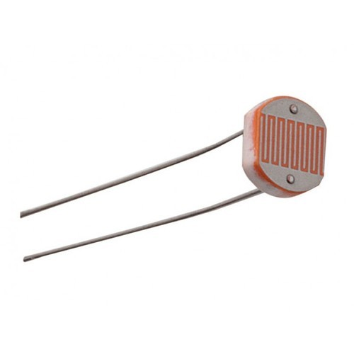

A photo resistor (or light-dependent resistor, LDR, or photo-conductive cell) is a light-controlled variable resistor. The resistance of a photo resistor decreases with increasing incident light intensity; in other words, it exhibits photoconductivity. It is made of a high resistance semiconductor.

**Working Principle of LDR** : These devices depend on the light, when light falls on the LDR then the resistance decreases, and increases in the dark. When a LDR is kept in the dark place, its resistance is high and, when the LDR is kept in the light its resistance will decrease

* **ARDUINO NANO**

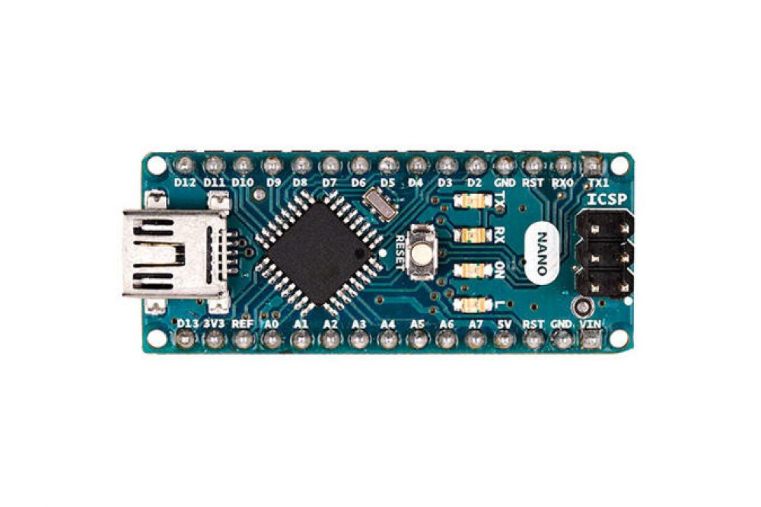

The Arduino Nano is a small, complete, and breadboard-friendly board based on the ATmega328 (Arduino Nano 3.x). It has more or less the same functionality of the Arduino Duemilanove, but in a different package. It lacks only a DC power jack, and works with a Mini-B USB cable instead of a standard one.

* **INFRARED SENSOR (IR SENSOR)**

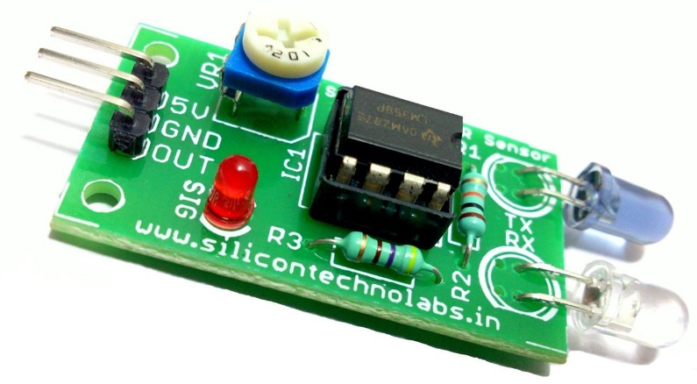

An infrared sensor is an electronic device, that emits in order to sense some aspects of the surroundings. An IR sensor can measure the heat of an object as well as detects the motion. These types of sensors measure only infrared radiation, rather than emitting it that is called as a passive IR sensor. Usually in the infrared spectrum, all the objects radiate some form of thermal radiations. These types of radiations are invisible to our eyes, that can be detected by an infrared sensor.

The emitter is simply an IR LED (Light Emitting Diode) and the detector is simply an IR photodiode which is sensitive to IR light of the same wavelength as that emitted by the IR LED. When IR light falls on the photodiode, resistances and the output voltages, change in proportion to the magnitude of the IR light received.

**Architecture Design of Smart Street Light Control System**



**Working:**

* Firstly, Arduino Board receives input from the sensors (LDR,) and the battery connected to the board.
* After processing the data input from LDR, if the input is below threshold voltage, IR Sensors get activated, and it determines, if object is present or not, and send back data to Arduino Board.
* If object is detected, the LED get ON, else it is in OFF mode.

**Future Aspects :**

By using Smart Street light, one can save surplus amount of energy. It prevents unnecessary wastage of electricity, caused due to manual switching of streetlights when it’s not required. It provides an efficient and smart automatic streetlight control system with the help of IR sensors. It can reduce the maintenance cost. The system is versatile, extendable and totally adjustable to user needs.

• The system here is now used only for one way traffic in highways.

• Continuous use of LDR and IR sensors even in day time.

• Not switched on before the sunset

The Smart light system can be further extended to make the current system in two-way traffic, making the system more flexible in case of rainy days and introduction of ways to control the lights through GSM based service.

The proposed streetlight automation system is a cost effective and the safest way to reduce power consumption. It helps us to get rid of today's world problems of manual switching and most importantly, primary cost and maintenance can be decreased easily. Moving to the new & renewable energy sources, this system can be upgraded by replacing conventional LED modules with the solar-based LED modules. Keeping in mind that these long-term benefits; the starting cost would never be a problem because the return time of investment is very less. This system can be easily implemented in street lights, parking lights of hospitals, airport, universities and industries etc.